**Lab Manual- Setup Apache web Server on Centos for Docker**

**Prepared for**:

**Date:** 18th Nov 2018

**Prepared by:** Shruti Sinhaa

Document Name: Lab Manual

**Document Number** DevOpsLab401

**Contributor:**

Table of Contents

1 OBJECTIVE 2

2 PRE-REQUISISTE 3

3 Lab Scenario 3

# OBJECTIVE

Deploying your software becomes a lot easier after Docker where you don’t have to worry about missing a system configuration or a prerequisite. In This Lab will cover the basics of installing Apache Webserv er on Centos and run Image with Docker containers expose on port 80.

* Pull latest Centos Image
* Create a container with Centos Image and Expose it on port 80
* Update the Centos Image
* Install Apache web server
* Start the Apache service
* Access the web site from browser using docker IP

# PRE-REQUISISTE

* Prior knowledge of Linux
* Prior knowledge of docker
* A local Computer with 4 CPU, 16 GB RAM, 200 GB disk space

# Lab Scenario

* Install apache inside a docker container and access it using the hosts IP.

docker pull centos

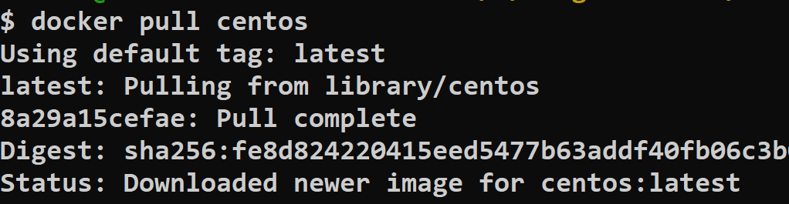

docker Images

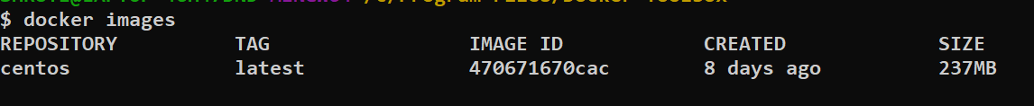

docker run – It --name myWebserver centos

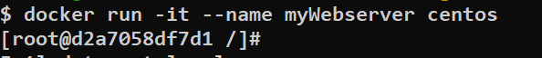

yum update -y

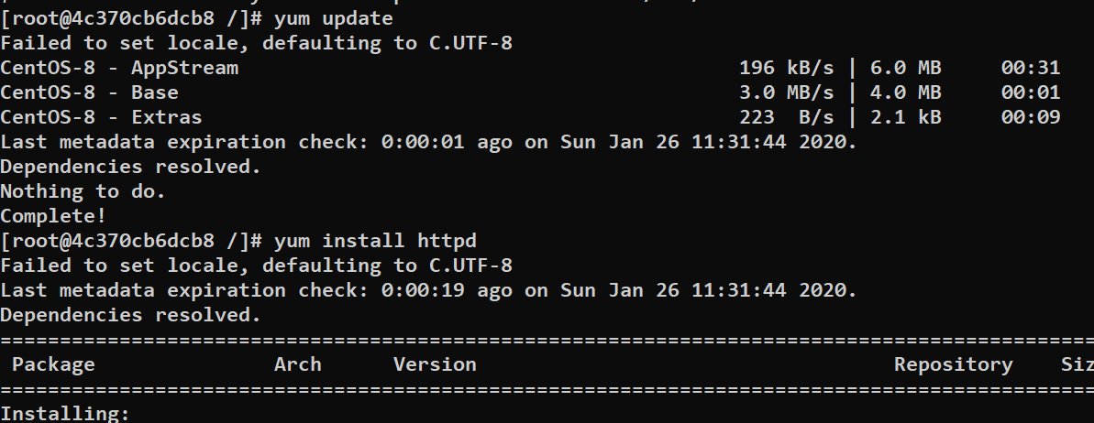

yum install httpd -y

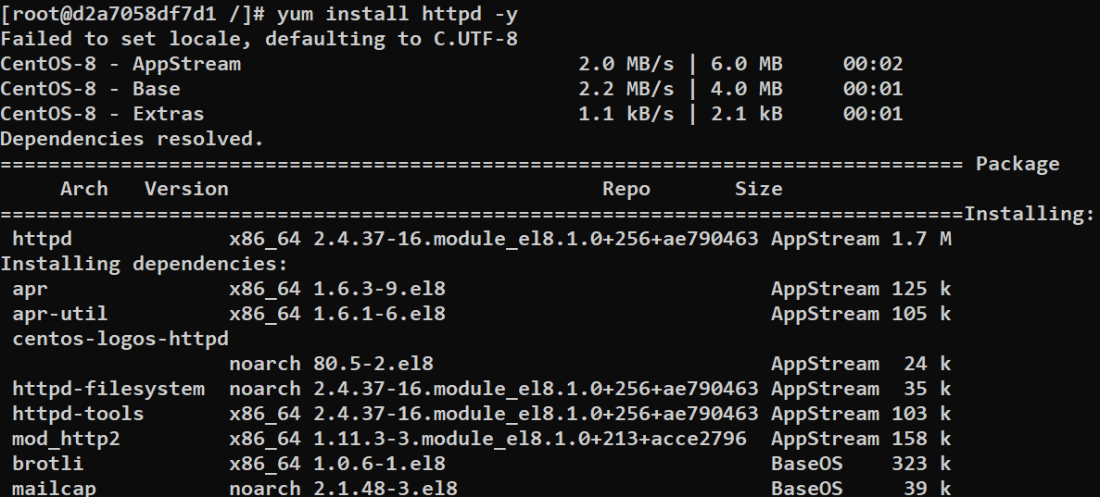

vi /var/www/html/index.html



<html>

<Body>

<h1> This is Lab exercise done by Candidate </h1>

<h2> Thank You for Joining DevOps </h2>

</body>

</html>

**[ Now Press ESC and press Shift+ : and type :WQ ]**

exit

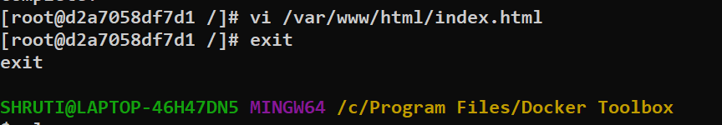

docker ps -a

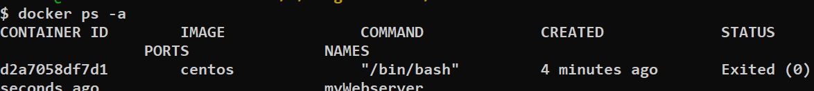

docker commit myWebserver shrutisinhaa/training:Apache2



docker Images

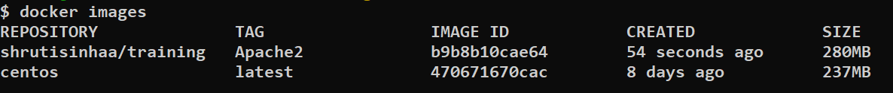

docker run -p 8081:80 shrutisinhaa/training:Apache2 /usr/sbin/httpd -D FOREGROUND



Now Open the Browser and type Ip withy port 8081

docker login

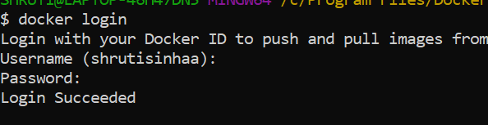

docker push shrutisinhaa/training:Apache2

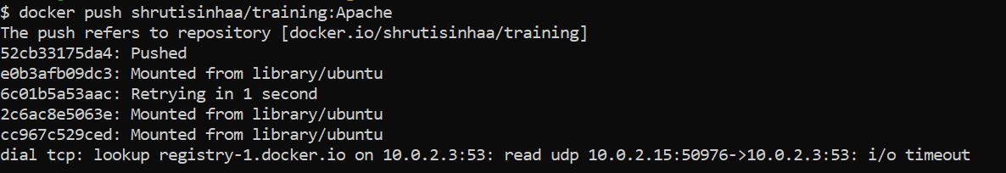

Check docker hub

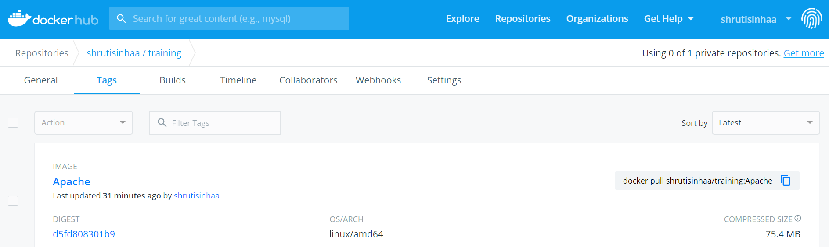

If we again need to make some changes inside this container, we need to attach to this container using docker attach command.

docker attach myWebServer

